Mini project
Batch no: DA TE-008
Faculty: Sunitha.v
Student name: M Nithin
Dataset link: https://data.telangana.gov.in/dataset/tgspdcl-ev-charging-stations-consumption-data

Project title: TGSPDCL EV Charging Stations Consumption Analysis Telangana
Data Visualization Using Power BI
Raw data:
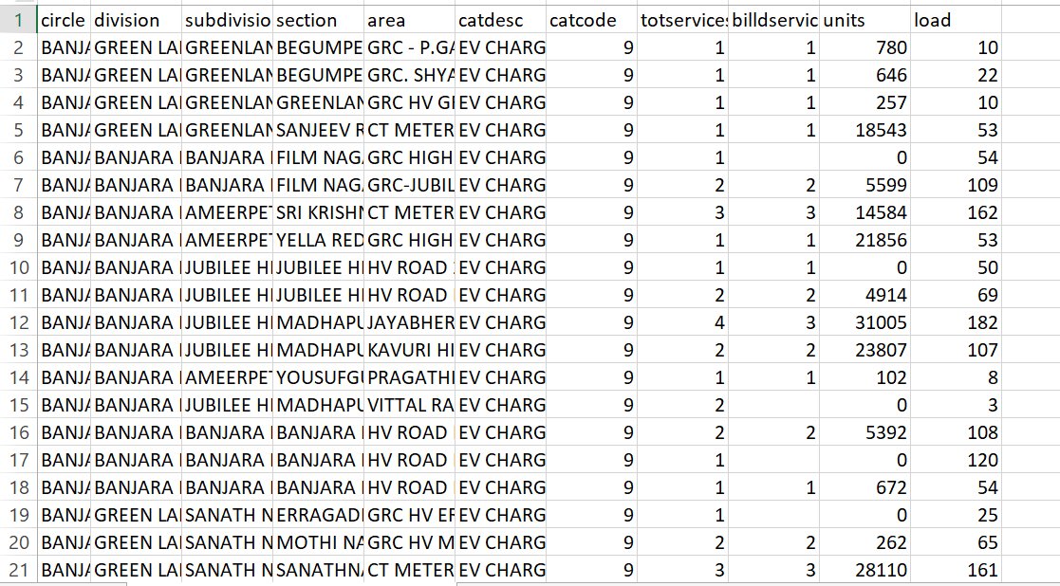

Cleaned data:
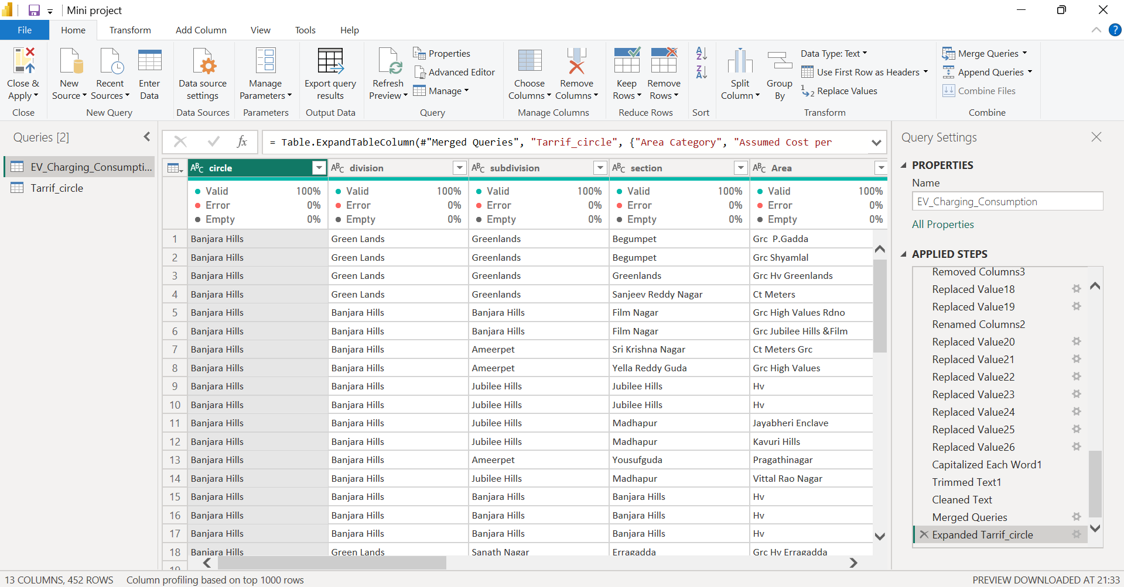
Model view:
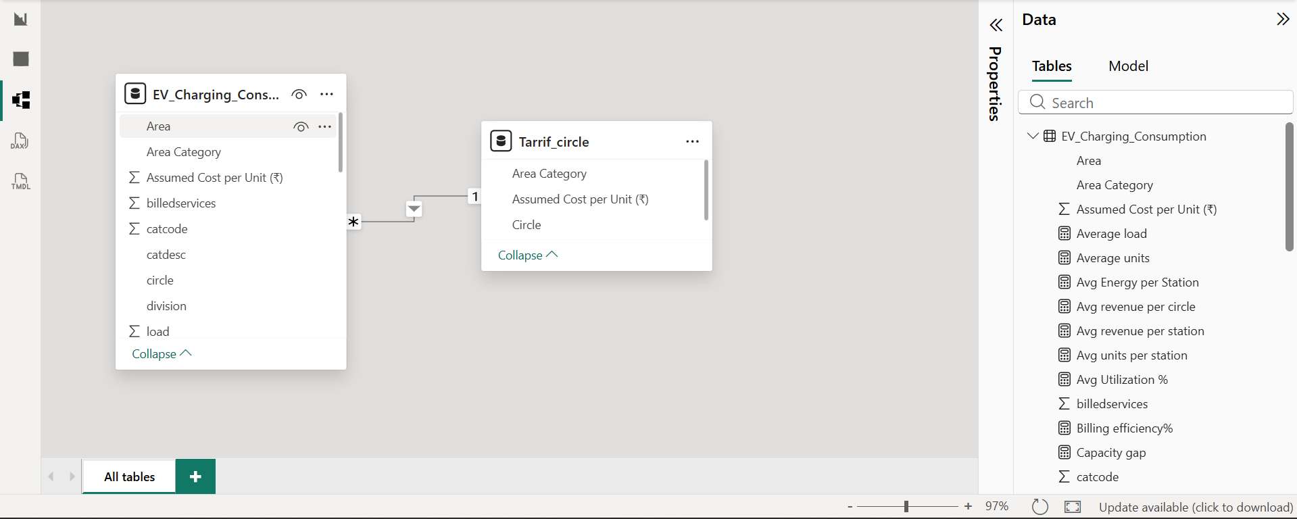
Overview Dashboard:
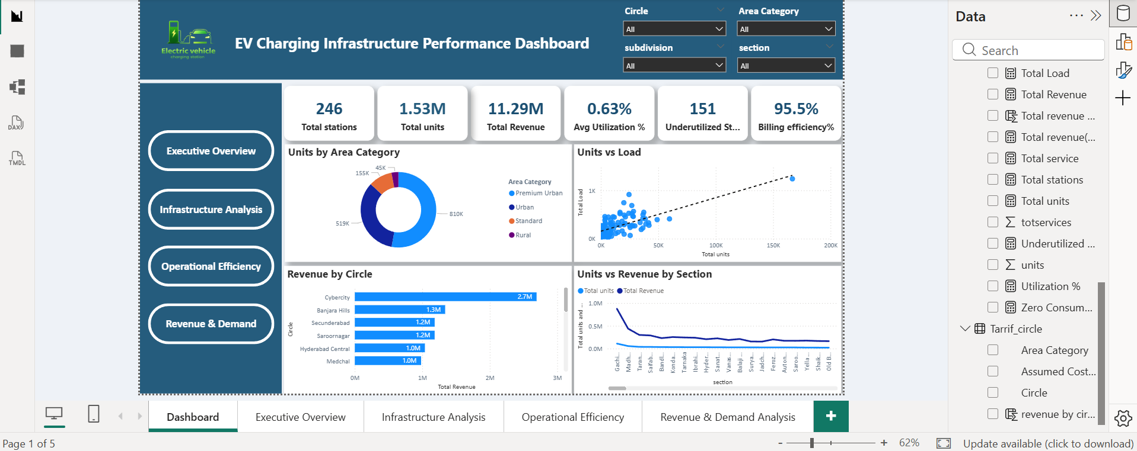

Conclusion:
Data visualization was performed using Microsoft Power BI to transform processed data into meaningful insights. Various interactive visualizations such as bar charts, line charts, gauge charts, and KPI cards were created to analyze EV charging station performance. These visuals help identify patterns like station utilization, revenue distribution, energy consumption, and demand trends. The dashboard enables users to monitor key metrics and make data-driven decisions efficiently.

